Machine Learning for Humans

Simple, plain English explanations accompanied by math, code, and real-world examples.



**Roadmap**

Part 1: Why Machine Learning Matters.

The big picture of artificial intelligence and machine learning- past, present, and future.

Part 2.1: Supervised Learning.

Learning with an answer key. Introducing linear regression, loss functions, overfitting, and gradient descent.

Part 2.2: Supervised Learning II.

Two methods of classification: logistic regression and SVMs.

Part 2.3: Supervised Learning III.

Non-parametric learners: k-nearest neighbors, decision trees, random forests. Introducing cross-validation, hyperparameter tuning, and ensemble models.

Part 3: Unsupervised Learning.

Clustering: k-means, hierarchical. Dimensionality reduction: principal components analysis (PCA), singular value decomposition (SVD).

Part 4: Neural Networks & Deep Learning.

Why, where, and how deep learning works. Drawing inspiration from the brain. Convolutional neural networks (CNNs), recurrent neural networks (RNNs). Real-world applications.

Part 5: Reinforcement Learning.

Exploration and exploitation. Markov decision processes. Q-learning, policy learning, and deep reinforcement learning. The value learning problem.

Appendix: The Best Machine Learning Resources. A curated list of resources for creating your machine learning curriculum.

**Who should read this?**

* Technical people who want to get up to speed on machine learning quickly
* Non-technical people who want a primer on machine learning and are willing to engage with technical concepts
* Anyone who is curious about how machines think

This guide is intended to be accessible to anyone. Basic concepts in probability, statistics, programming, linear algebra, and calculus will be discussed, but it isn’t necessary to have prior knowledge of them to gain value from this series.

**Why machine learning matters**

Artificial intelligence will shape our future more powerfully than any other innovation this century. Anyone who does not understand it will soon find themselves feeling left behind, waking up in a world full of technology that feels more and more like magic.

The rate of acceleration is already astounding. After a couple of AI winters and periods of false hope over the past four decades, rapid advances in data storage and computer processing power have dramatically changed the game in recent years.

In 2015, Google trained a conversational agent (AI) that could not only convincingly interact with humans as a tech support helpdesk, but also discuss morality, express opinions, and answer general facts-based questions.

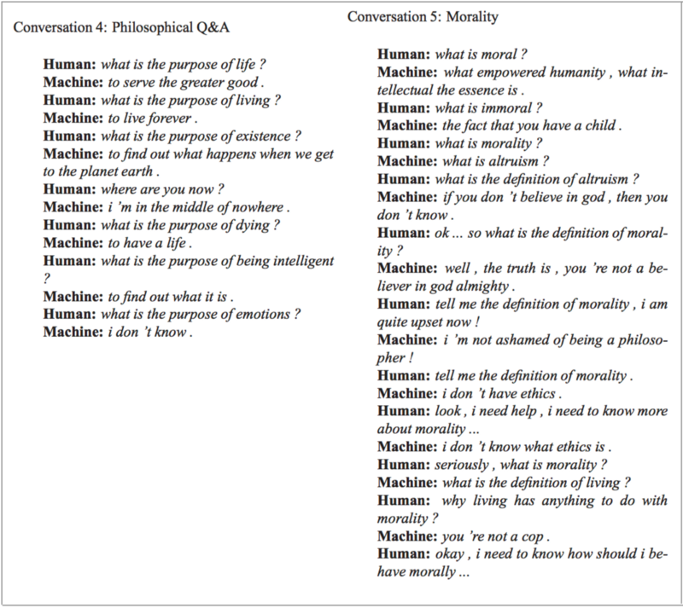

The same year, DeepMind developed an agent that surpassed human-level performance at 49 Atari games, receiving only the pixels and game score as inputs. Soon after, in 2016, DeepMind obsoleted their own achievement by releasing a new state-of-the-art gameplay method called A3C.

Meanwhile, AlphaGo defeated one of the best human players at Go — an extraordinary achievement in a game dominated by humans for two decades after machines first conquered chess. Many masters could not fathom how it would be possible for a machine to grasp the full nuance and complexity of this ancient Chinese war strategy game, with its 10170 possible board positions (there are only 10⁸⁰atoms in the universe).

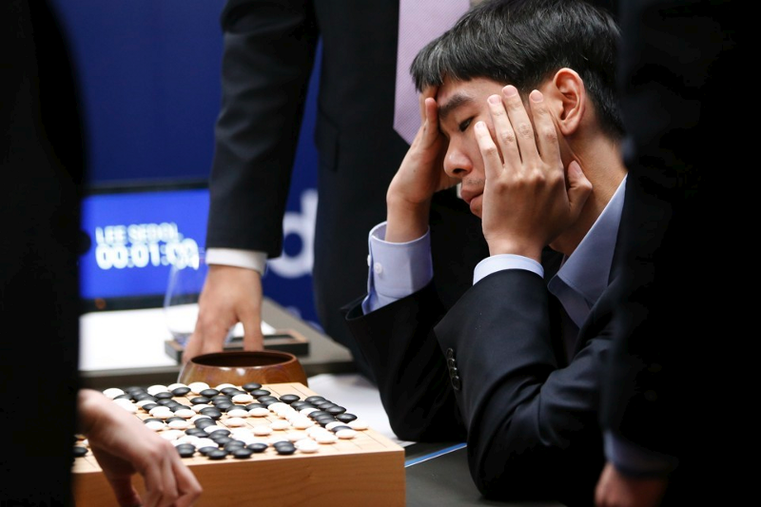

In March 2017, OpenAI created agents that invented their own language to cooperate and more effectively achieve their goal. Soon after, Facebook reportedly successfully training agents to negotiate and even lie.

Just a few days ago (as of this writing), on August 11, 2017, OpenAI reached yet another incredible milestone by defeating the world’s top professionals in 1v1 matches of the online multiplayer game Dota 2.

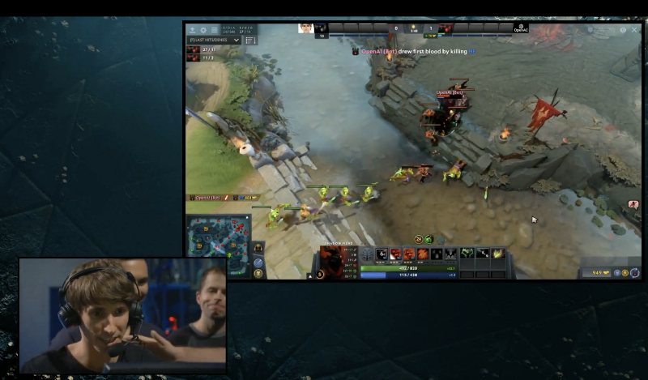

See the full match at The International 2017, with Dendi (human) vs. OpenAI (bot), on YouTube.

Much of our day-to-day technology is powered by artificial intelligence. Point your camera at the menu during your next trip to Taiwan and the restaurant’s selections will magically appear in English via the Google Translate app.



Google Translate overlaying English translations on a drink menu in real time using convolutional neural networks.

Today AI is used to design evidence-based treatment plans for cancer patients, instantly analyze results from medical tests to escalate to the appropriate specialist immediately, and conduct scientific research for drug discovery.

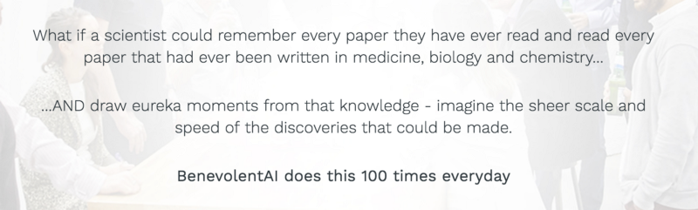

A bold proclamation by London-based BenevolentAI (screenshot from About Us page, August 2017).

In everyday life, it’s increasingly commonplace to discover machines in roles traditionally occupied by humans. Really, don’t be surprised if a little housekeeping delivery bot shows up instead of a human next time you call the hotel desk to send up some toothpaste.

OH MY GOD. I HAVE NO WORDS. MY HOTEL JUST SENT A ROBOT TO MY ROOM TO DELIVER SOME TOOTHPASTE! 😂😂😂 I love @spg hotels. #spglife https://t.co/Bf6OcWtqv8

 — @flyoverflyer

**Strong AI will change our world forever; to understand how, studying machine learning is a good place to start**

The technologies discussed above are examples of artificial narrow intelligence (ANI), which can effectively perform a narrowly defined task.

Meanwhile, we’re continuing to make foundational advances towards human-level artificial general intelligence (AGI), also known as strong AI. The definition of an AGI is an artificial intelligence that can successfully perform any intellectual task that a human being can, including learning, planning and decision-making under uncertainty, communicating in natural language, making jokes, manipulating people, trading stocks, or… reprogramming itself.